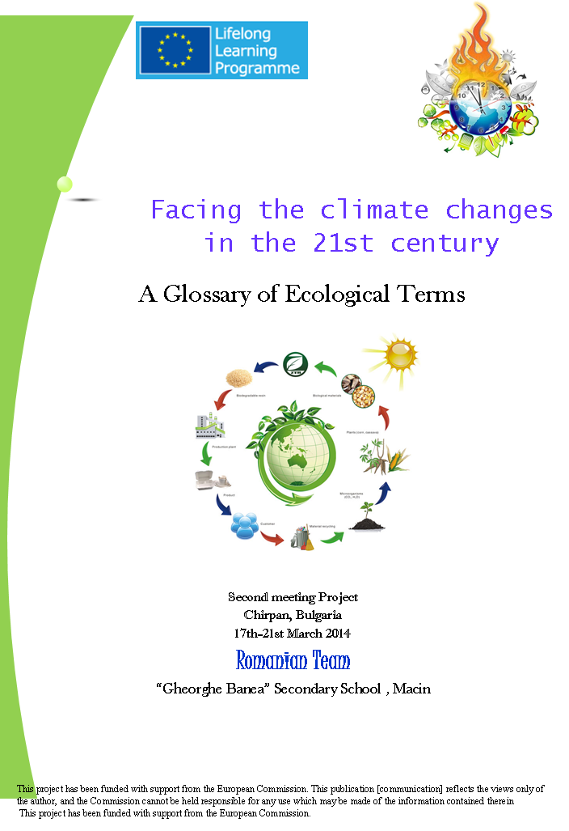
Alternative energy

energy derived from sources that do not use up natural resources or harm the environment

Biodegradable
If something is biodegradable, it can decompose naturally. When you're out camping, you shouldn't leave anything behind and certainly nothing that isn't biodegradable. A plastic bottle is the antithesis of biodegradable — it will be there forever.

Biodiversity
When you have a many different plants and animals living in one place, you have biodiversity. The Amazon rain forest is rich in biodiversity.

Carbon cycle
the organic circulation of carbon from the atmosphere into organisms and back again

Conservation
Conservation is when you keep something from running out — whether it's plants, animals, or resources. Your new conservation project, "Save the Pigeons," might not catch on as quickly as you'd hoped.

Deforest

remove the trees from

Ecology

The noun ecology describes the environment as it connects to living things, or the branch of biology that studies that environment.

Ecosystem

An ecosystem is all the living things, from plants and animals to microscopic organisms, that share an environment. Everything in an ecosystem has an important role. Well, almost everything.

Environment
Think of the environment as everything that is around you. A quiet room with good lighting and no distractions is a good environment for doing homework, or at least that's what your parents and teachers think.

Habitat
Your habitat is the environment you are accustomed to living in. Zoos usually try to mimic the habitats of the animals they keep, housing bats in a nocturnal house and monkeys in a cage with trees to climb and swing from.

Litter
If everyone decided to litter, or drop trash on the ground, the world would be covered in garbage. Litter doesn't always have to be trashy though. When a cat has kittens, they are born as a litter.

Ozone
Ozone is a colorless toxic gas formed from oxygen by an electrical discharge. It’s that stuff in the sky that comes between you and the sun.

Ozone hole

an area of the ozone layer (near the poles) that is seasonally depleted of ozone

Ozone layer

a layer in the stratosphere (at approximately 20 miles) that contains a concentration of ozone sufficient to block most ultraviolet radiation from the sun

Pollution
Pollution is unwanted, harmful stuff contaminating an environment. The race to develop clean energy is motivated by high levels of pollution that people fear are permanently damaging the earth's environment.

Recyclable

capable of being used again

Renewable

Anything renewable can be replaced or has an endless supply. Renewable sources of energy don't run out.

Ecology Glossary

abiotic - nonliving factors in the environment. The abiotic factors of the environment include light, temperature, soil, climate and atmospheric gases.
biotic - pertaining to life or living things.
carnivore - organism that eats meat for energy.
consumer - organism that consumes another organism as food for energy.
community - the region occupied by a group of interacting organisms
decomposer - organisms that breakdown organic material.
ecology- the study of how living (biotic) and nonliving (abiotic) parts of the environment interact with each other
ecosystem - a system formed by the interaction of a community of organisms with their physical environment.
food chain -An interconnected chain of organisms that indicate which are predators and which are prey in relation to one another.
habitat - the natural environment of a plant or animal.
herbivore - organisms that eat plants for energy.
niche - the ecological role of an organism in a community.
omnivore - organism that eats plants and meat for energy.
organism - any living thing that has living characteristics and is composed of one or more cells.
population - all the organisms that constitute a specific group or occur in a specified habitat.
producer - organisms that use the sun for producing food.
species - organisms that can reproduce with each other.

